**CALCULATOR APP DOCUMENTATION**

1. **Introduction:**

Calculator is a web-based application built with HTML, CSS, and JavaScript. It provides basic arithmetic operations such as addition, subtraction, multiplication, and division. Additionally, the application includes operations like add, multiply, divide and subtract. It also maintains a history of calculations performed. It also includes clear button and delete button.

1. **Functionality:**

* appendValue(value): Appends the specified value to the display when a button is clicked.
* clearDisplay(): Clears the display.
* calculate(): Evaluates the expression on the display and updates the result.
* memoryRecall(): Recalls the value stored in memory and displays it.
* memoryClear(): Clears the stored memory
* memoryAdd(): Adds the current display value to the stored memory.
* memorySubtract(): Subtracts the current display value from the stored memory.

1. **Features:**

* Basic Arithmetic Operations: The calculator supports addition, subtraction, multiplication, and division.

1. **Conclusion:**

Simple Calculator is simple, yet functional web-based calculator that allows users to perform basic arithmetic calculations while also storing and managing the results in a history. The memory functionality further enhances its usability, and error handling ensures that users are notified of any issues with their input.

**Screenshots of output:**

1. 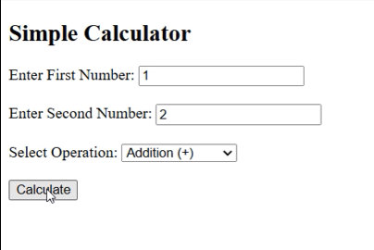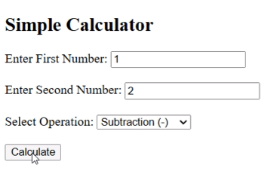

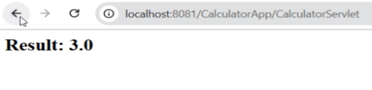 

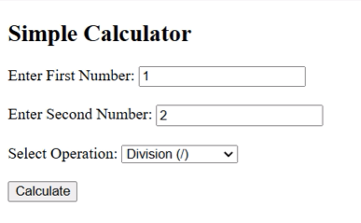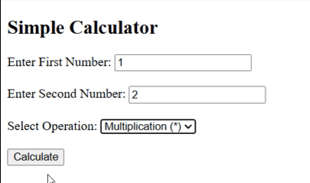

** **

**G.Harshitha**

**IOT Alpha**